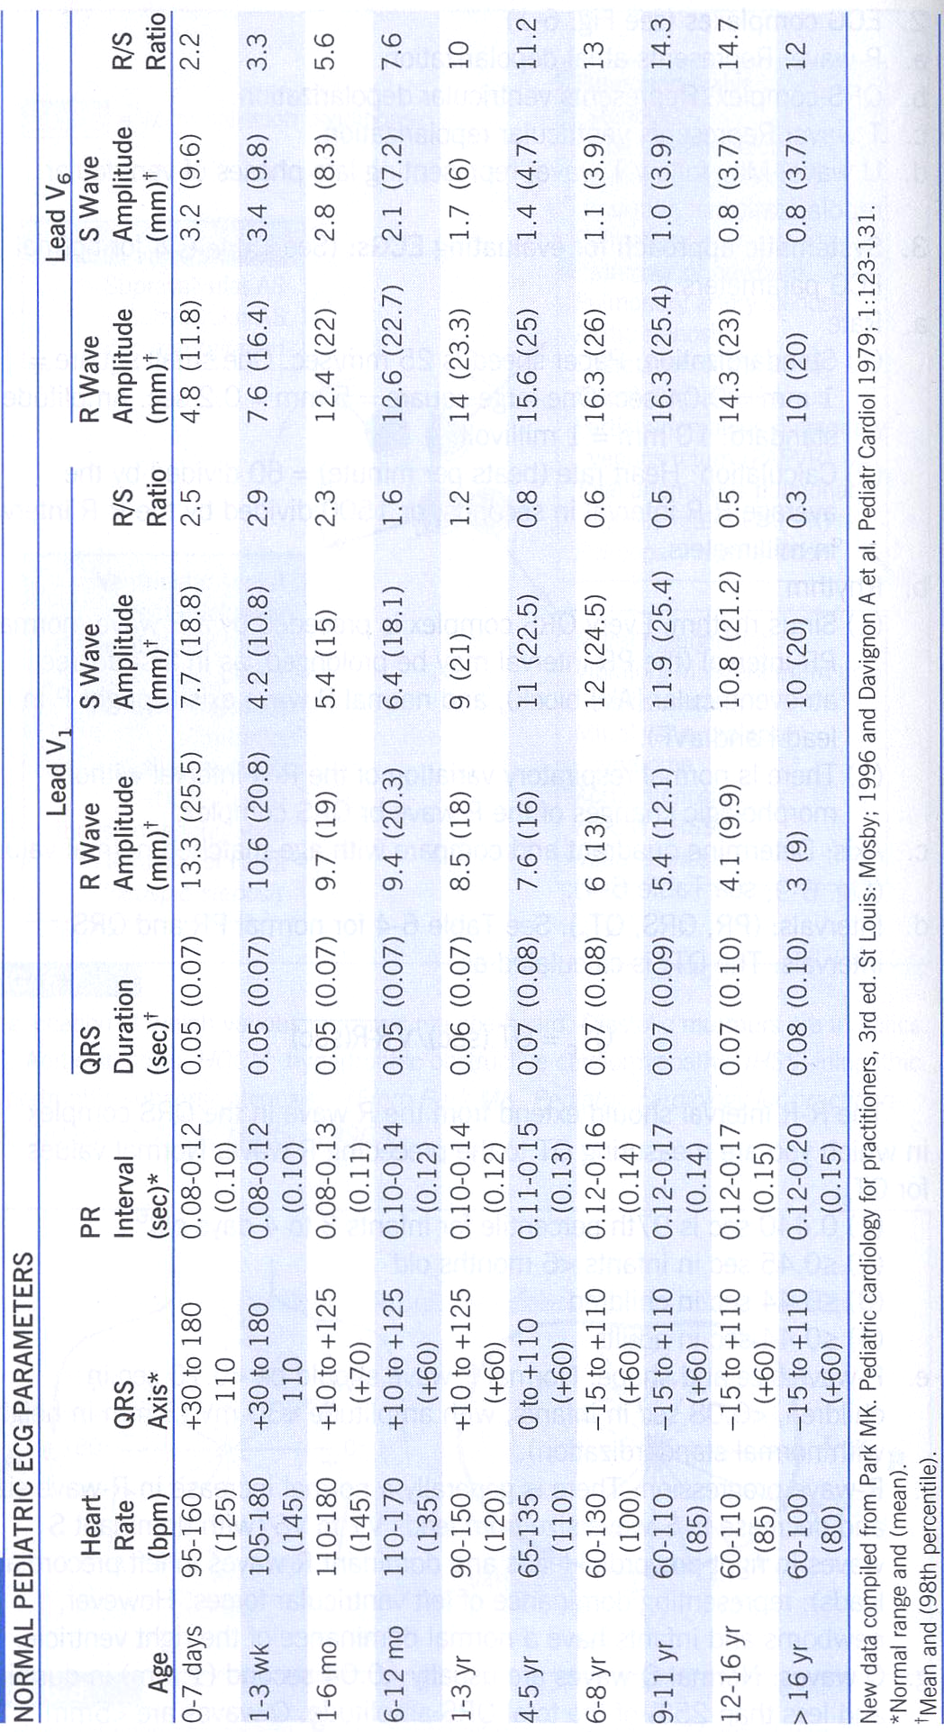
EKG Findings with Medications:
-Digoxin:
Brady, 1° AVB,
ST depress, tall R
Dig Tox:
Brady, 2/3° AVB,
PAC, SVT, PVC,
V tach.
-Quinidine/
Procainamide/
Disopyramidine:
Prolonged QRS,
Prolonged QTc
Toxicity:
Tachy, wide P,
1° AVB, QRS &
QTc ↑ prolonged,
PVC, V tach.
-β-Blockers:
Brady, 1° AVB,
shorter QTc.
-Anesthetics
Halothane/
Methoxyflurane/
Teflurane/
Enflurane:
Shorter QTc, T-
wave depress,
brady, ventricular
arrhythmias.
-Phenothiazines:
↓ T amplitude w/
prominent end
repolarization
(looks like U),
prolonged QTc.
-TCA’s:
Sinus tach, flat T,
1° AVB, ST/T
Δ’s, prolonged
QRS/QTc.
-Imipramine Tox:
A flutter, AVB,
V tach.

EKG Findings with Electroyte Δ’s and Systemic Disease:
↑ K: (5.5-6.5) – tall, peaked T, (>7) – wide P, (>8) – absent P, (>9) – AV block, V tach, V fib.
↓ K: flat T, ST depression, prominent U-wave.
↑ Ca: Short ST segment, sinus brady or arrest. ↓ Ca: Prolonged ST segment → prolonged QTc, nl QRS.
↑ Mg: Prolonged PR, shorter ST segment → short QTc.
↓ Mg: Prolonged ST segment & prolonged repolarization → prolonged QTc, prominent U-wave.
CNS injury: ↑ vagal tone → bradycardia, AV block, J-wave.
Hypothermia: Sinus brady, prolonged PR and QTc, J-wave.
Hyperthyroid: Sinus tach, LVH, prolonged PR, non-specific ST or T-wave Δ’s.
Hypothyroid: Sinus brady, absent ST; low P, QRS, & T-wave voltages.

Small square (1mm) = 0.04 sec. Large square (5mm) = 0.2sec. Amplitude: 1mm = 0.1mV.
Rate: 300, 150, 100, 75, 60, 50. (300/ # large boxes).
Rhythm: Every QRS preceded by P; normal PR; upright P in I and aVF.
May have normal variation w/ respiration, if no morphologic Δ’s of P or QRS.
Axis: |  | Quick QRS Axis:  *Northwest axis  Normal T-wave Axis:
  I | ↑ | ↑ | ↓ | ↓
  aVF | ↑ | ↓ | ↑ | ↓
  Axis | Nl | L-dev | R-dev | NW*
  Age | V1, V2 | aVF | I, V5, V6
  Birth – 1 day | ± | + | ±
  1 – 4 days | ± | + | +
  4 days – adolesc. | – | + | +
  Adolesc. – adult | + | + | +

Intervals: see table for PR & QRS.
QTc = QT / √ (preceding R-R); normal ≤ 0.44 sec (≤ 0.45 for infants < 6 months)
P wave: kids < 0.10 sec (2.5 sm box); infants < 0.08 sec (2 sm box); amplitude < 3mm.
Q wave: normal < 0.04 sec (1 sm box); amplitude < 25% of total QRS
(for kids < 3 y/o, amplitude < 5 mm in V4-V6 and ≤ 8 mm in III).
R wave progression: from V1 to V6, R size ↑ & S size ↓, except infants.
ST wave elevation/depression: >1mm in limb leads, >2mm V1-V6 c/w myocardial injury.
T wave changes: tall, peaked in ↑K, flat/low in ↓K, ↓thyroid, ischemia/inflamm., or nl.
Hypertrophy: see table for 98th %ile’s for age.
RVH: have at least one of the following:
1. R in V1 AND S in V6 both > 98th %ile for age.
2. Upright T in V1 after DOL#3 (before adolescence).
3. Supplemental: Q wave in V1, RAD, and RV strain (inverted T w/ tall R in V1).
LVH:
1. R in V6 (and V5, I, & aVL) > 98th %ile; and/or S in V1 > 98th %ile for age.
2. Supplemental: LAD, volume overload (Q & tall T in V5-6), and
LV strain (inverted T in V6, I, or aVF).
BBB: RBBB = RSR’ in V1, slurred S in V6; LBBB = RSR’ in V6, slurred S in V1.
Arrythmias:
- Sinus tach: NSR with HR > 95th %ile for age (and usually < 230 bpm).
- Sinus brady: NSR with HR < 5th %ile for age.
- PAC: narrow QRS, abnormal P and normal QRS.
- A flutter: rate 250-300, sawtooth pattern (no discrete P), variable ventricular response.
- A fib: atrial rate 350-600, ventricular response rate 110-150, fibrillation, nl QRS.
- SVT: Run of ≥3 premature supraventricular beats at >230bpm, narrow QRS & abnl P.
3 types: AV reentrant, AV nodal/junctional, ectopic atrial. Sustained = > 30 sec.
- Nodal Escape/Junctional: P buried in preceding QRS/T, retrograde P (↓ in II, ↑ in aVR).
- PVC: Premature wide QRS w/ compensatory pause. Bi/trigeminy = alternating nl/abnl.
- V tach: Run of ≥3 PVC’s at 120-250bpm, wide QRS, dissociated/retrograde/no P wave.
- V fib: Abnl QRS of varying size/morphology w/ irregular rapid rate.
Heart Block:
- 1st°: Prolongation of PR interval.
- 2nd° (Mobitz I/Wenckebach): Progressive lengthening of PR interval until QRS skipped.
- 2nd° (Mobitz II): Paroxysmal skipped QRS without progressive lengthening of PR interv.
- 3rd° (Complete): Complete dissociation of P and QRS.
Pre-excitation:  - Wolff-Parkinson-White: tall R, short PR, wide QRS w/ δ-wave. |  |  | 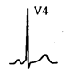
- Lown-Ganong-Levine: short PR, narrow QRS.
- Mahaim Conduction: normal PR, wide QRS.

+
+

